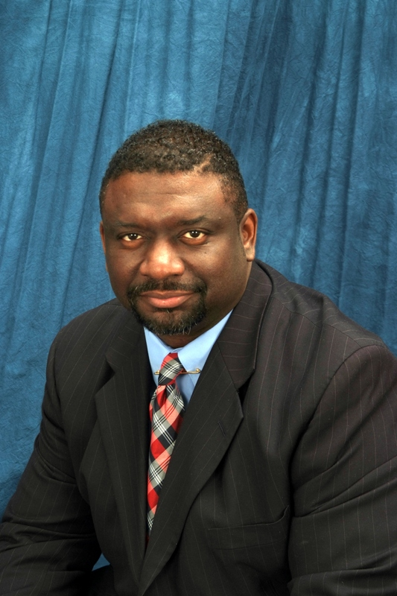

About our Pastor, Dr. John H. Curry, Jr.

Our pastor Rev. Dr. John H. Curry, Jr., was born December 10th 1964 to his beloved parents the Late Rev. John H. Curry, Sr., and Mrs. Betty Curry in Troy (Pike County) Alabama. He is the Oldest of Seven Children. He attended the schools of Troy, Alabama. Pastor Curry was called to the ministry at the early age of 10 years old. He preached his first sermon on December 5th 1976 to a waiting and expecting crowd. He was licensed in the ministry that same night at the Bethel Missionary Baptist Church under the Pastorate of the Late Rev. Dr. L. C. McMillan. Under the tutelage of his late father and pastor, Rev. John H. Curry, Jr. grew in statue in the ministry and remained a humble, committed and a sincere servant to his calling. Rev. Curry, while still a student in Charles High School, was ordained as a minister and called to his first church in March 1983, The New Zion Missionary Baptist Church of Brundidge, Alabama. Rev. Curry reflects often about this first ministry experience at New Zion. This church had 15 members and 1 deacon. They paid Pastor Curry a salary of $25.00 a month. The New Zion Church Family gave him a surprise raise for his first year anniversary of $10.00. This is where the journey in pastoral ministry began.

Pastor furthered his educational career by graduating from the following colleges:

* Associate of Arts Degree Selma University, Selma, Alabama; May, 1983
* Bachelors of Science, Political Science and Government, Auburn University at Montgomery. December, 1991
* Masters’ of Education, Elementary Education, Auburn University at Montgomery, May, 2000
* Administrative/Supervision Certification, Educational Leadership, Auburn University at Montgomery, July, 2002
* Doctorate of Divinity in Leadership, New Wine School of Ministries October, 2003
* Selected to Receive, second honorary Doctorate from Thomas Grove Christian College, Ft. Lauderdale, Florida, in 2010
* Currently Completing his Doctorate in Ministry Andersonville Theological Seminary, Camilla, Georgia

Prior to coming to Tuskegee, Pastor Curry pastored the following churches:

1983-1985- New Zion Missionary Baptist Church, Brundidge, Alabama

1983-87- Rock Elvy Missionary Baptist Church, Shady Grove, Alabama

1984-1987- New Hope Valley Baptist Church, Luverne, Alabama.

1987-1993- St. Paul Missionary Baptist Church, Greenville, Alabama

1994- Present- The Historic Mt. Olive Missionary Baptist Church, Tuskegee, Alabama.

Because his love of children and education, Pastor Curry has taught school for a number of years and became an instructional leader when he accepted the responsibility to serve in the position of Assistant Principal, Notasulga High School, and South Macon Elementary School from 2002-2005 in the Macon County Public School System. Rev. Curry also served as the first supervisor for Macon County’s first ever Macon County 21st Century Community Learning Center grades K-8 from 2002-2005. From 2005-2007 served as the Assistant Principal at the Tuskegee Institute Middle School. Rev. Curry was reassigned as Assistant Principal of Notasulga High School in July 2007. In 2011, he was assigned to the George Washington Carver Elementary School as Assistant Principal. In August 2012, Dr. Curry was promoted to his current position as ***Technology Coordinator***, for Macon County School System, Tuskegee, Alabama.

His love and compassion for the Church house and the schoolhouse has had its impact on the Tuskegee Community. Pastor Curry is a current member of the local, state, and national Education association as well as a member of the local, state, and national Baptist Conventions of America. He has served on several committees and boards. He was recently appointed a member of the Tuskegee University Teacher Education Council; President/C.E.O of the first Mt. Olive Community Development Corporation. This organization came out of a vision of Pastor Curry to establish a non-profit faith based organization for social enhancement and ministry to the community. It is a 501c3 non-profit organization. He is a member of the Omega Psi Phi Fraternity, Iota Omega Chapter, and Tuskegee, Alabama. He is loved and honored by many. In May 2005 Pastor Curry received an Award for Excellence in Education. He was honored and designated by the National Society of Pershing Rifles for Excellence in Education. He has received numerous awards from schools, programs and organizations. He is Great Pastor, Preacher, Speaker, Motivator and lecturer in the lecture circuit.

Some of his most proud accomplishments are leading the Mt. Olive Missionary Baptist Church toward a successful building ministry and program to fulfill the vision, which God gave him. “The Mount” which he compassionately calls Mt. Olive is one of the most progressive and powerful ministries in Tuskegee. The Church has grown by leaps and bounds in all facets of its ministries. It has become a beaconing light of hope for the community, city, state and the nation. December of 2009, Pastor Curry received ***the Light of Hope Silver Award*** for his work in the Community as a Pastor and Educator. He was honored with the Rev. Dr. Clay Evans of Chicago, Illinois and others from Georgia, South Carolina and Alabama. The event took place in Atlanta, Georgia’s Hilton Inn Millennial Center.

Perhaps the his greatest is his beautiful wife of 26 years, the former Ms. Brenda Johnson and their three beautiful children Brandon Javon, 23, Brittany Jenna, 21, and Brentic John, 18. The first letter in each child’s first and middle name is a symbol of the love and union of Brenda and John. Pastor Curry continues to fulfill his calling through loving and charismatic leadership in the church and community.